Executions of existed functions:
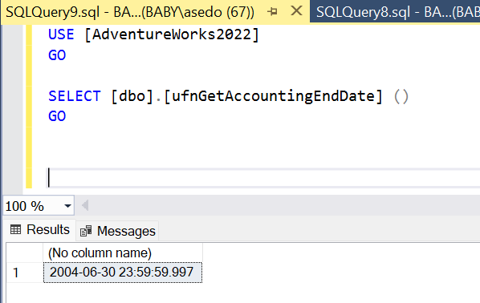

1.

ALTER FUNCTION work_func(@jobtitle VARCHAR(40))
RETURNS TABLE
AS
RETURN
(
SELECT TOP (75) PERCENT Person.FirstName, Person.LastName, Employee.VacationHours
FROM HumanResources.Employee
INNER JOIN Person.Person ON Employee.BusinessEntityID = Person.BusinessEntityID
WHERE Employee.JobTitle = @jobtitle
ORDER BY Employee.VacationHours ASC
);

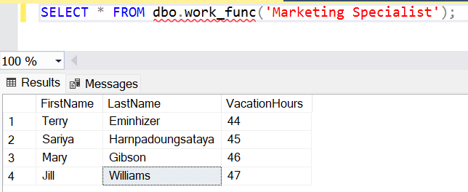

2.
ALTER FUNCTION salary_rate(@person_id INT)
RETURNS MONEY
AS
BEGIN
DECLARE @salary MONEY;
SELECT TOP (75) PERCENT @salary = EmployeePayHistory.Rate
FROM HumanResources.EmployeePayHistory
WHERE BusinessEntityID = @person_id
RETURN @salary;
END;
